Football Season Organizer

Author(s) Joshua Ruiz

CST-451 Capstone Project Proposal

Grand Canyon University

Instructor: Professor Mark Reha

Revision: 08/20/2023

Date:08/20/2023

**ABSTRACT**

Summarize the entire project in 2-3 paragraphs, about 15-20 lines. The abstract should be enough for one to get an idea of what this project is about, what was the task, and what you accomplished. Briefly provide the broader context. Write this section only after the entire project is complete.

|  |
| --- |
| History and Signoff Sheet |

**Change Record**

|  |  |  |
| --- | --- | --- |
| **Date** | **Author** | **Revision Notes** |
| 08/20/2023 | Joshua Ruiz | Initial draft for review/discussion |
|  |  |  |
|  |  |  |

|  |
| --- |
| **Overall Instructor Feedback/Comments** |

|  |
| --- |
| **Overall Instructor Feedback/Comments** |

**Integrated Instructor Feedback into Project Documentation**

Yes  No

**Project Approval**

Professor Mark Reha

**TABLE OF CONTENTS**

Project Overview and Project Objectives 4

Project Scope 5

Project Success Measures 6

Project High-Level Solution 7

Project Controls 8

Project Cost and Schedule 10

Appendix A – References 11

Appendix B – Copyright Compliance 12

Project Overview and Project Objectives

**State the Problem and Background**

The purpose of this project is to allow a simple way to gather data for both college and NFL games during football season. The idea came about as my wife and I have trouble always remembering or figuring out which teams are playing on what day and on which network we can find them. This app will allow me to input the data as soon as the NCAA and NFL schedules are released and then utilize the application to get a calendar output that shows each game for the teams that we select. Due to where my wife and I grew up our NFL teams are the Raiders and Cowboys and our NCAA teams are Cornhuskers, UCLA, University of Texas, and potentially UT San Antonion if our adopted son starts to play there next year. It takes along time to compile all of these schedules manually (which my wife did this year because she is amazing) so it gave me the idea to put together something that could potentially automate this process for us.

**Christian Worldview**

The football organizer application would be more of a secular item; however, it is possible to utilize it as a way to organize Christians together to watch games, fellowship and even potentially create relationships between people Christians and non-Christians where the Gospel can be shared. As I am writing this I believe that there may be a way to integrate this type of application into something like Evite to make it easier to create football watch parties for the games giving us more opportunities to fellowship with other Christians and witness to those who are non-Christians.

**Project Objectives**

The objectives of this will be simple:

1. Are we able to integrate the football data into a database and get it to feed into the application.
2. Does the application allow for a user to sign-in and select their favorite teams and are those favorites saved correctly for the user.
3. Does the application allow for a UI interface that renders the applicable team data for the end user so they can track the games they would like to watch or record.
4. Do the email reminders work correctly so that the end-user is notified about upcoming games in advance so they can plan accordingly. (May need to have a notification feature that allows for different timing on notifications.
5. Does the application save time when trying to compile all of the teams that the end user wants to watch during a football season.

**Challenges**

1. Obtaining football data for NFL and NCAA teams in a timely manner. APIs may or may not be available to pull the data down so manual inputs into the database may be required. If this is the case then only a handful of teams will be entered to make sure the project can be completed on time.
2. Security – is any end user personal data and passwords secured during the applications use.
3. UI usability – User acceptance testing will be required to make sure that the UI is usable and helpful.

**Benefits and Opportunities**

The benefits for this application are mainly personal. This application will be for my wife and I to better organize our football seasons each year. It will also give me practice with creating, maintaining and updating an application. I will also be able to use this as a sample for future job postings and projects. I have already integrated a lot of principles learned through programming into my reporting designs and have improved my skill set tremendously.

Project Scope

1. The scope of the project will include the following:
   1. SQL database that can store NFL game schedule data, NCAA game schedule data, HS game schedule data, favorites, and login credentials
   2. User Interface that can display game data in both list and calendar formats
   3. Create profile & Login functionality
   4. Ability to save NFL and NCAA teams into profile to pull down a specific schedule football schedule. Game data will include, Date, Time, Network its playing on, Home or Away game.
   5. Application notifications about upcoming games each week.
   6. Input form to allow for High School game schedules to be input. This form will allow for an entire season of games to be input. (Ex: my adopted son plays highschool football so I will be able to put his teams data into the app.)
2. Use the template to list all known stakeholders and contacts, if applicable, including self (for some projects self may be the only name listed)

|  |  |  |
| --- | --- | --- |
| Stakeholder Name | Role(s) | Responsibilities |
| Joshua Ruiz | Developer | Entire development process and application maintenance |
| Rachael Ruiz | Spouse | End-user of app so she no longer has to manually compile our football season schedules |

1. List the work breakdown required to satisfy the project objectives. Identify teams and other resources that may be required to successfully complete the project.

|  |  |  |  |  |  |  |  |  |  |  |
| --- | --- | --- | --- | --- | --- | --- | --- | --- | --- | --- |
| Work Breakdown Structure | | | | | | | | | | |
| ID | Task | Dependencies | Status | Effort Hours | Cost | Start Date | Planned Completion | Estimate to Completion | Actual Completion | Resource |
| 1 | Create/Design SQL database for Storage | All Data components | Not Started | 2 | 0 | 08/21/2023 | 8/23/2023 | 0% | 0% | MySQL |
| 2 | Create Classes for Application | Business Logic and UI | Not Started | 2 | 0 | 08/21/2023 | 08/24/2023 | 0% | 0% | Spring Boot |
| 3 | Create Business Logic for Application | UI and Basic Functionality | Not Started | 3 | 0 | 8/28/2023 | 9/03/2023 | 0% | 0% | Spring Boot |
| 4 | Create Security Functions | All Application components | Not Started | 4 | 0 | 9/04/2023 | 9/11/2023 | 0% | 0% | Spring Boot |
| 5 | Create UI for Application | UI | Not Started | 8 | 0 | 9/12/2023 | 9/17/2023 | 0% | 0% | Angular or React |
| 6 | UAT | All | Not Started | 8 | 0 | 9/18/2023 | 9/25/2023 | 0% | 0% | Wife will be my tester |

Project Success Measures

|  |
| --- |
| Project Completion Criteria |
| 1 – Able to import game schedule data and manually input games into the application utilizing an import tool/form |
| 2 - UI is able to pull game data into a calendar and list format |
| 3 – Users are able to create login credentials and sign in to create favorites |
| 4 – Users are able to select favorite teams and save them to their profile to view schedules |
| 5- Users will be able to receive notifications of upcoming games for that week when logged into the application |

1. Use the template to list the project assumptions and constraints, if applicable. An assumption is an educated guess that a likely condition or circumstance is presumed to be true. A constraint is a limiting condition or circumstance that defines the project boundaries. Assumptions allow the project to succeed. Constraints restrict or limit the project execution.

|  |  |  |  |  |  |
| --- | --- | --- | --- | --- | --- |
| Assumptions and Constraints | | | | | |
| ID | Description | Comments | Type | Status | Date Entered |
| 1 | Game Schedule data will be readily available to collect and input into the database | APIs or manually searching will allow for games schedules and data to be input into the database | Assumption | Valid | 08/20/2023 |
| 2 | Limited ability to input data into database | Will only be able to enter a few NFL and NCAA teams schedules into the database due to time constraints for project. | Constraint | Valid | 8/20/2023 |

Project High-Level Solution

**Introduction**

The high-level solution is to create an application that will allow my wife and I to input football game schedule data for Professional and Collegiate level teams into a database that will then output the results in a calendar/list format to make keeping track of our football watch schedules easier. It will require football schedule data to be readily available, but this iteration of the project will only contain a few teams from each level in order to give a proof of concept rather than a fully integrated application.

**Solution**

The solution will be made up of a simple SQL database with tables to store game data, login credentials, and user profiles, a basic UI that will allow the user to login/create an account, save teams to their favorites, and then pull the schedules for those teams into a Calendar or list format for the season. The application will utilize reminders to help the user keep track of the date, time, and broadcasting network for each game through the use of notifications each week. The application will be simple, but useful for our private utilization. The main idea will be to make an application that works, then each season add more functionality to it like integration into an Evite or email system. Basic wireframes and draft UML for login and Teams class attached for reference. Will continue to update as the project develops and new classes are created.

Wireframe Mock-up:

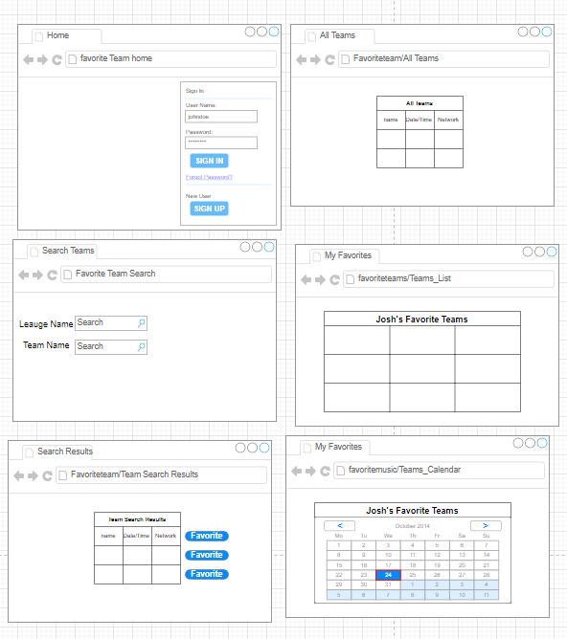

UML Classes – User registration & Login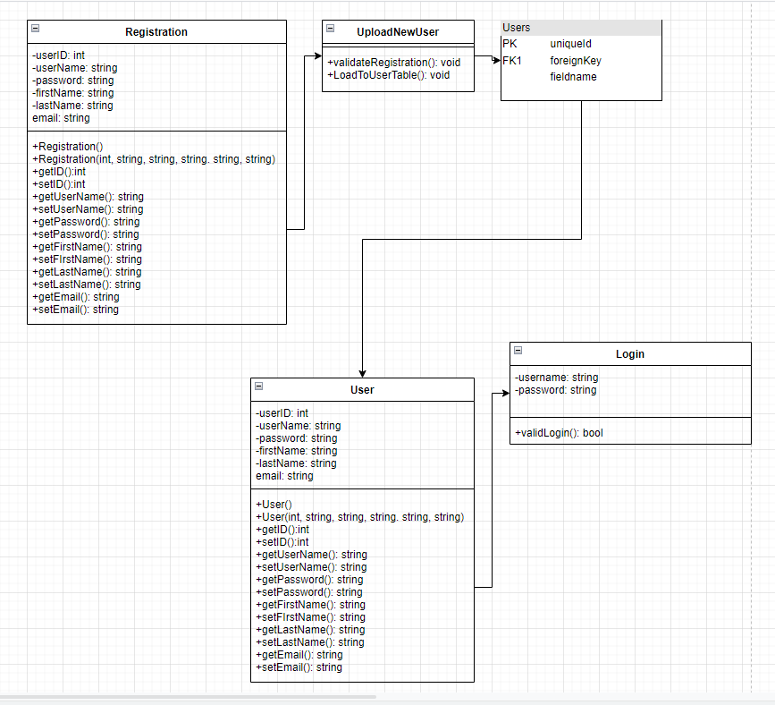

UML Team Class:

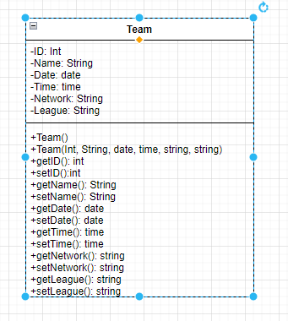

Project Controls

1. Use the template to define the risk and list the steps to prevent the risk from occurring or the steps to minimize the chances of it happening. The contingency plan describes alternative solutions to reduce the impact of the risk. An example of a contingency plan is to provide the customer a temporary web server if there are delays in delivery/completion. If the risk has already happened then provide an entry in the issue log.

|  |  |  |  |  |
| --- | --- | --- | --- | --- |
| Risk Management | | | | |
|  | **Risk Probability** | **Risk Impact** |  |  |
| **Event Risk** | **(high, medium, low)** | **Risk Mitigation** | **Contingency Plan** |
| What is the risk? | What is the probability? | What is the impact if the risk occurs? | What can be done to minimize the risk? | What can be done to minimize the impact of the risk? |
| Developer Inexperience | 50% | Delays on project completion | Engage professor and other sources with help in development | Ask for assistance as soon as hit an impasse while programming |
| Time constraints | 100% | Delays due to professional work schedule and family needs | Will need to integrate the development into part of the work day to make sure time is set aside each day to complete tasks | Will utilize Vacation time as project gets closer to due date to ensure time is available to complete tasks. |
|  |  |  |  |  |

|  |  |  |  |  |  |  |  |  |
| --- | --- | --- | --- | --- | --- | --- | --- | --- |
| Issues Log | | | | | | | | |
| **ID** | **Description** | **Project Impact** | **Action Plan/Resolution** | **Owner** | **Importance** | **Date Entered** | **Date to Review** | **Date Resolved** |
| 1 | What is the issue? | How will this impact scope, schedule & cost? | How do you intend to deal with this issue? | Who manages this issue? |  |  |  |  |
| 2 |  |  |  |  |  |  |  |  |
| 3 |  |  |  |  |  |  |  |  |

1. All projects have either anticipated and planned or unexpected changes. Describe any issues in management or change management due to the anticipated and planned or unexpected changes. Use the template to list anticipated and planned or unexpected changes.

|  |  |  |  |  |  |  |  |  |  |
| --- | --- | --- | --- | --- | --- | --- | --- | --- | --- |
| Change Control Log | | | | | | | | | |
| **ID** | **Change Description** | **Priority** | **Originator** | **Date Entered** | **Date Assigned** | **Evaluator** | **Status** | **Date of Decision** | **Included in Rev. #** |
| 1 | May need to utilize non NFL/NCAA team names | High | Josh | 8/20/2023 | 8/20/2023 |  |  | Unkown |  |
| 2 |  |  |  |  |  |  |  |  |  |

1. Use the template to describe how the end user is involved in the software development, if applicable. Include relevant information about meetings, reviews, presentations, etc.

|  |  |  |  |
| --- | --- | --- | --- |
| Roles and Responsibilities | | | |
| Name | Team | Project Role | Responsibility |
| Joshua Ruiz | Sole Developer | Lead Developer | All development responsibilities |
|  |  |  |  |

Project Cost and Schedule

1. Project will not require any costs

Project schedule (subject to revision) is found in the work breakdown section. As are the work breakdown and time estimates for the project. All estimates are subject to revision depending needs/ future constraints

Appendix B – Copyright Compliance

For each external technical tool or code used, provide a reference to its copyright policy, clearly showing your right to use it. For each external technical tool or code used, detail how you used it, how you adapted it, how you modified it (if permitted), and why did you use it as opposed to write your own. Only a small portion of your project may rely on external code. When code libraries/packages are used, explain why this was necessary/required/recommended. Seek instructor approval for using external resources prior to beginning to work on the project.